Build your home library  Have a variety of texts available at home for your child to read. Visit the library to check out new materials often but also consider purchasing some of your child’s favorite books. For those of you with children who “don’t like to read”, here are non-book reading materials from scholastic.com: magazines, comics, manuals, newspapers, travel brochures, poetry, encyclopedias, sports programs, catalogs, recipes, dictionaries, play scripts, atlases and books they have written. Be sure to also include a variety of fiction, non-fiction and informational texts. http://www.scholastic.com/parents/blogs/scholastic-parents-raise-reader/15-reading-materials-arent-books |  |  | Happy Reading!  Additional Resources  -Calendar of reading activities:  http://www.justreadfamilies.org/greatideas/middle.asp?style=print  -Great parent reading guide:  http://www.peireads.com/photos/original/learntoread.pdf  -Organized book lists for preteens  http://www.goodreads.com/list/tag/preteen  Further questions? Contact me!  Email: bwisnor@bgsu.edu  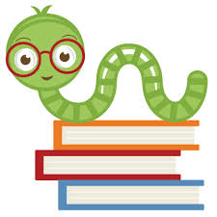 Literacy acquisition and development |  |  | 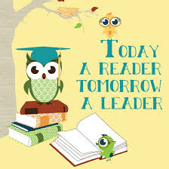  Literacy acquisition and development  - By: Ms. Breanna Wisnor

Read in front of your child  This may seem silly but by reading in front of your child, you are proving that you value and enjoy reading. Reading in front of children demonstrates the importance of reading every day and allows parents and teachers to “practice what they preach”. Being a reading role model for your children will inspire them to read and to understand the meaning of being a life-long learner. |  |  | Discuss what you are reading  After having a shared reading experience, discuss your thoughts on what you read. This discussion could follow a book you read-a-loud together or a book you both read on your own. Talking about books helps improve vocabulary and critical thinking skills. By talking about what you read, you will be able to share your thoughts and insights, help each other reflect on what you read and come to better understand the text and each other.  Set Reading Expectations  By establishing a reading routine, your child will come to love and appreciate reading. Find a schedule that works for you and try to be as consistent as possible to prove that reading and learning is a priority. Set a specific amount of time for reading together and independently aside each day. Help your child establish specific reading goals to motivate him/her.  http://www.peireads.com/photos/original/learntoread.pdf  http://www.peireads.com/photos/original/learntoread.pdf |  |  | Read to your child  Just because your children can read on their own does not mean there is no need for you to read to them. Aside from strengthening the bond you have with your child, reading aloud to them will take their listening comprehension to the next level and help them grow as readers.  Select books to read aloud that are higher than their independent reading level. This will motivate them to listen and advance their comprehension.  http://www.greatschools.org/students/7104-read-aloud-to-children.gs
http://www.peireads.com/photos/original/learntoread.pdf

